Lab 11 – Data Structures with AI: Implementing Fundamental
Structures
Task Description #1 – Stack Implementation
Task: Use AI to generate a Stack class with push, pop, peek, and is_empty
methods.
Sample Input Code:
class Stack:
pass
Expected Output:
• A functional stack implementation with all required methods and
docstrings.
PROMPT:
Generate a Python Stack class with the following methods:
- push(item) – add an item to the top.
- pop() – remove and return the top item.
- peek() – return the top item without removing it.
- is_empty() – check whether the stack is empty.
Use a Python list to store the elements. Include class and method docstrings, basic error handling, comments, and a simple example. Follow PEP 8 guidelines.
CODE:
"""A simple stack implementation using a Python list."""

class Stack:
"""A last-in, first-out (LIFO) collection."""

def __init__(self):
"""Initialize an empty stack."""
self._items = []

def push(self, item):
"""Add an item to the top of the stack."""
self._items.append(item)

def pop(self):
"""Remove and return the top item.

Raises:
IndexError: If the stack is empty.
"""
if self.is_empty():
raise IndexError("pop from an empty stack")
return self._items.pop()

def peek(self):
"""Return the top item without removing it.

Raises:
IndexError: If the stack is empty.
"""
if self.is_empty():
raise IndexError("peek from an empty stack")
return self._items[-1]

def is_empty(self):
"""Return True if the stack contains no items."""
return not self._items

if __name__ == "__main__":
# Demonstrate basic stack operations.
stack = Stack()
stack.push("first")
stack.push("second")
print(stack.peek()) # second
print(stack.pop()) # second
print(stack.is_empty()) # False
OUTPUT:
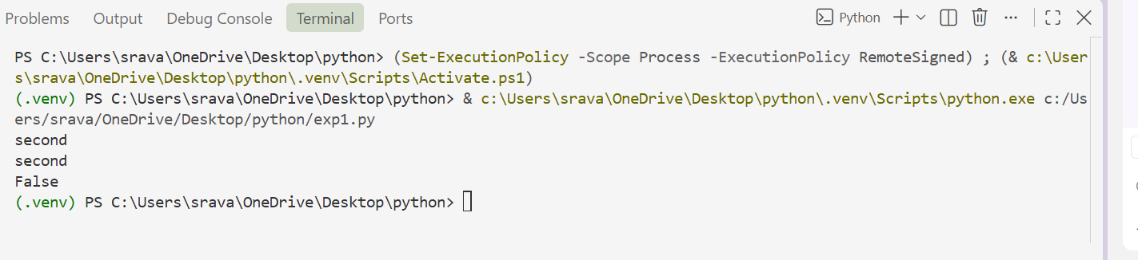
Task Description #2 – Queue Implementation
Task: Use AI to implement a Queue using Python lists.
Sample Input Code:
class Queue:
pass
Expected Output:
• FIFO-based queue class with enqueue, dequeue, peek, and size
methods.
PROMPT:
Implement a FIFO Queue in Python using a list.
Include the following methods:
- enqueue(item) to add an item.
- dequeue() to remove and return the first item.
- peek() to view the first item.
- size() to return the number of items.
Include docstrings, comments, error handling, and a simple example. Follow PEP 8 style guidelines.
CODE:
"""A simple FIFO queue implementation backed by a Python list."""

class Queue:
"""A first-in, first-out (FIFO) queue."""

def __init__(self):
"""Initialize an empty queue."""
self._items = []

def enqueue(self, item):
"""Add ``item`` to the end of the queue."""
self._items.append(item)

def dequeue(self):
"""Remove and return the first item.

Raises:
IndexError: If the queue is empty.
"""
if not self._items:
raise IndexError("dequeue from empty queue")
return self._items.pop(0)

def peek(self):
"""Return the first item without removing it.

Raises:
IndexError: If the queue is empty.
"""
if not self._items:
raise IndexError("peek from empty queue")
return self._items[0]

def size(self):
"""Return the number of items in the queue."""
return len(self._items)

if __name__ == "__main__":
queue = Queue()
queue.enqueue("first")
queue.enqueue("second")

print(queue.peek()) # Output: first
print(queue.dequeue()) # Output: first
print(queue.size()) # Output: 1
OUTPUT:
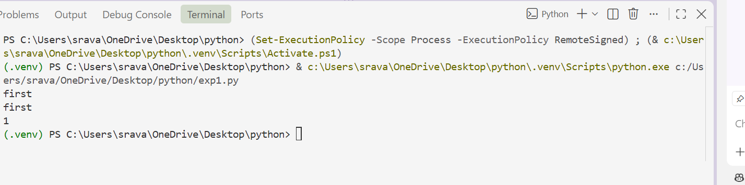
Task Description #3 – Linked List
Task: Use AI to generate a Singly Linked List with insert and display
methods.
Sample Input Code:
class Node:
pass
class LinkedList:
pass
Expected Output:
• A working linked list implementation with clear method
documentation.
PROMPT:
Generate a Python implementation of a singly linked list.
Create:
- A Node class containing data and a reference to the next node.
- A LinkedList class.
- An insert(data) method to insert a new node.
- A display() method to display all nodes.
- Clear docstrings and comments.
Provide a simple example and follow PEP 8 guidelines.
CODE:
"""A simple singly linked list implementation."""
class Node:
"""A node that stores data and a reference to the next node."""
def __init__(self, data):
"""Initialize a node with data and no next node."""
self.data = data
self.next = None

class LinkedList:
"""A singly linked list with insertion and display operations."""
def __init__(self):
"""Initialize an empty linked list."""
self.head = None
def insert(self, data):
"""Append data to the end of the linked list."""
new_node = Node(data)
if self.head is None:
self.head = new_node
return current = self.head
while current.next is not None:
current = current.next
current.next = new_node

def display(self):
"""Print all node values in order, followed by None."""
current = self.head
values = []
while current is not None:
values.append(str(current.data))
current = current.next
values.append("None")
print(" -> ".join(values))

if __name__ == "__main__":
linked_list = LinkedList()
linked_list.insert(10)
linked_list.insert(20)
linked_list.insert(30)
linked_list.display()
OUTPUT:
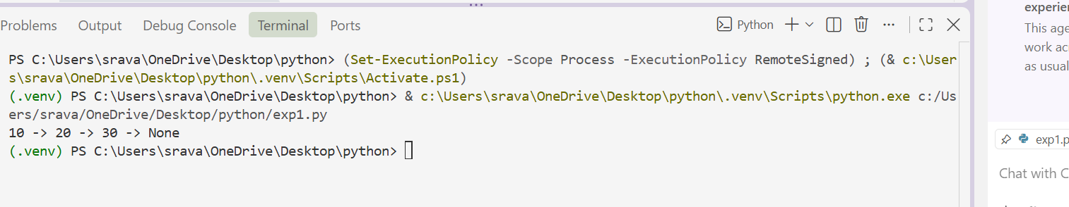
Task Description #4 – Binary Search Tree (BST)
Task: Use AI to create a BST with insert and in-order traversal methods.
Sample Input Code:
class BST:
pass
Expected Output:
• BST implementation with recursive insert and traversal methods.
PROMPT:
Create a Python Binary Search Tree implementation.
Requirements:
- Create a node containing data, left, and right references.
- Implement recursive insertion.
- Implement recursive in-order traversal.
- Smaller values should be placed on the left and larger values on the right.
- Include docstrings and comments.
- Provide a demonstration with sample values.
Follow PEP 8 guidelines.
CODE:
"""A simple binary search tree implementation."""

class Node:
"""A tree node containing data and references to its children."""

def __init__(self, data):
"""Initialize a node with no children."""
self.data = data
self.left = None
self.right = None

class BinarySearchTree:
"""Store comparable values in a binary search tree."""

def __init__(self):
"""Create an empty binary search tree."""
self.root = None

def insert(self, data):
"""Insert data recursively; duplicate values are ignored."""
self.root = self._insert_recursive(self.root, data)

def _insert_recursive(self, node, data):
"""Return the subtree root after inserting data into that subtree."""
if node is None:
return Node(data)

if data < node.data:
node.left = self._insert_recursive(node.left, data)
elif data > node.data:
node.right = self._insert_recursive(node.right, data)
# Equal values are not inserted, keeping the tree free of duplicates.
return node

def in_order_traversal(self):
"""Return the tree's values in ascending order using recursion."""
values = []

def traverse_recursive(node):
if node is not None:
traverse_recursive(node.left)
values.append(node.data)
traverse_recursive(node.right)

traverse_recursive(self.root)
return values

if __name__ == "__main__":
tree = BinarySearchTree()
sample_values = [50, 30, 70, 20, 40, 60, 80]

for value in sample_values:
tree.insert(value)

print("In-order traversal:", tree.in_order_traversal())
OUTPUT:
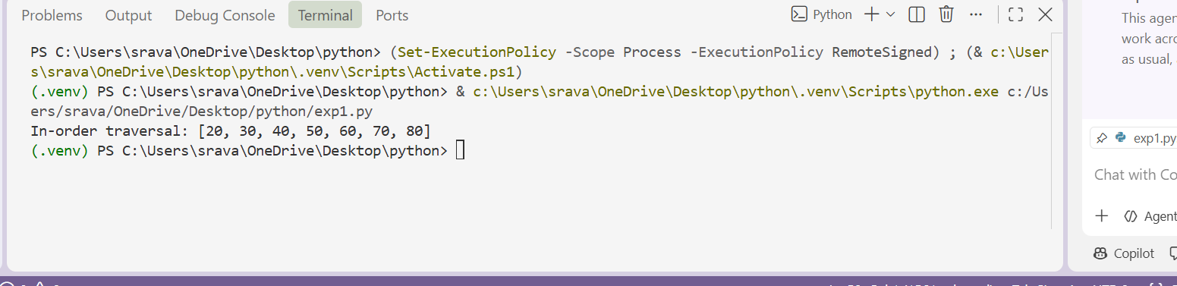
Task Description #5 – Priority Queue
Task: Use AI to implement a priority queue using Python’s heapq
module.
Sample Input Code:
class PriorityQueue:
pass
Expected Output:
• Implementation with enqueue (priority), dequeue (highest priority),
and display methods.
PROMPT:
Implement a Python Priority Queue using the heapq module.
The class must contain:
- enqueue(item, priority) to add an item with a priority.
- dequeue() to remove the highest-priority item.
- display() to show the queue.
Include docstrings, comments, error handling, and an example. Use clean PEP 8-compliant code.
Treat a smaller priority number as a higher priority.
CODE:
"""A simple priority queue implemented with :mod:`heapq`."""

import heapq
from itertools import count
from typing import Any, List, Tuple

class PriorityQueue:
"""A min-heap queue where smaller priority values are served first."""

def __init__(self) -> None:
"""Create an empty priority queue."""
self._heap: List[Tuple[Any, int, Any]] = []
self._sequence = count()

def enqueue(self, item: Any, priority: Any) -> None:
"""Add an item with its priority.

Items with equal priorities are served in insertion order. Priorities
must be mutually comparable; otherwise ``TypeError`` is raised.
"""
try:
heapq.heappush(self._heap, (priority, next(self._sequence), item))
except TypeError as exc:
raise TypeError(
"priority must be comparable with existing priorities"
) from exc

def dequeue(self) -> Any:
"""Remove and return the item with the smallest priority.

Raises:
IndexError: If the queue is empty.
"""
if not self._heap:
raise IndexError("dequeue from an empty priority queue")
return heapq.heappop(self._heap)[2]

def display(self) -> None:
"""Print items in dequeue order without modifying the queue."""
if not self._heap:
print("Priority queue is empty.")
return

# Each entry has a unique sequence number, so items need not compare.
for priority, _, item in sorted(self._heap):
print(f"Priority: {priority}, Item: {item}")

if __name__ == "__main__":
queue = PriorityQueue()
queue.enqueue("Write report", 2)
queue.enqueue("Handle urgent issue", 1)
queue.enqueue("Plan meeting", 3)

queue.display()
print("Dequeued:", queue.dequeue())
queue.display()
OUTPUT:
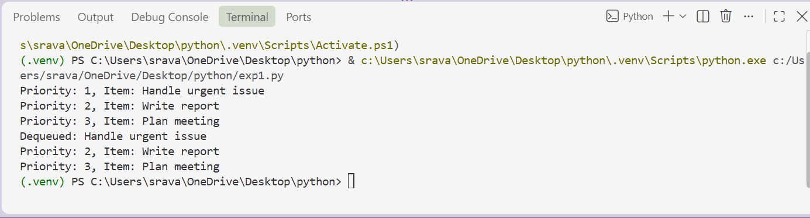
Task Description #6 – Deque
Task: Use AI to implement a double-ended queue using
collections.deque.
Sample Input Code:
class DequeDS:
pass
Expected Output:
• Insert and remove from both ends with docstrings.
PROMPT:
Implement a double-ended queue in Python using collections.deque.
The class should provide:
- insert_front(item)
- insert_rear(item)
- remove_front()
- remove_rear()
- display()
Include class and method docstrings, comments, empty-deque handling, and a simple example. Follow PEP 8 guidelines.
CODE:
"""A double-ended queue backed by :class:`collections.deque`."""

from collections import deque

class DoubleEndedQueue:
"""Support insertion and removal at both ends of a queue."""

def __init__(self):
"""Create an empty double-ended queue."""
self._items = deque()

def insert_front(self, item):
"""Insert an item at the front of the queue."""
self._items.appendleft(item)

def insert_rear(self, item):
"""Insert an item at the rear of the queue."""
self._items.append(item)

def remove_front(self):
"""Remove and return the front item, or ``None`` if empty."""
if not self._items:
# There is no item to remove from an empty queue.
return None
return self._items.popleft()

def remove_rear(self):
"""Remove and return the rear item, or ``None`` if empty."""
if not self._items:
# There is no item to remove from an empty queue.
return None
return self._items.pop()

def display(self):
"""Return a list of items in front-to-rear order."""
return list(self._items)

if __name__ == "__main__":
queue = DoubleEndedQueue()
queue.insert_front(2)
queue.insert_rear(3)
queue.insert_front(1)
print(queue.display()) # [1, 2, 3]
print(queue.remove_front()) # 1
print(queue.remove_rear()) # 3
print(queue.display()) # [2]
OUTPUT:
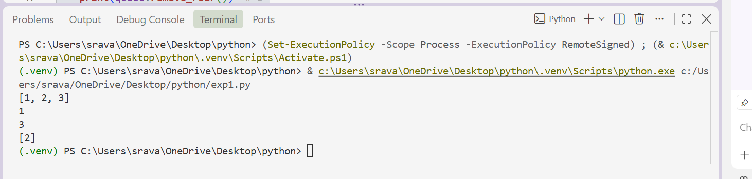
Task Description #7 Real-Time Application Challenge – Choose the
Right Data Structure
Scenario:
Your college wants to develop a Campus Resource Management System
that handles:
1. Student Attendance Tracking – Daily log of students
entering/exiting the campus.
2. Event Registration System – Manage participants in events with
quick search and removal.
3. Library Book Borrowing – Keep track of available books and their
due dates.
4. Bus Scheduling System – Maintain bus routes and stop
connections.
- Cafeteria Order Queue – Serve students in the order they arrive.
PROMPT:
Create a Python cafeteria order management system using a Queue.
Requirements:
- Follow the FIFO principle.
- Create a class for managing cafeteria orders.
- Provide methods to add and serve orders.
- Provide a method to display pending orders.
- Include comments and docstrings.
- Demonstrate the system with three student orders.
- Follow PEP 8 guidelines.
CODE:
"""Manage cafeteria orders using a first-in, first-out queue."""

from collections import deque

class CafeteriaOrderManager:
"""Store and serve student orders in the order they are received."""

def __init__(self):
"""Create an empty queue of pending orders."""
self._orders = deque()

def add_order(self, student, items):
"""Add a student's order to the end of the queue."""
order = {"student": student, "items": items}
self._orders.append(order)
print(f"Added order for {student}: {items}")

def serve_order(self):
"""Serve and return the oldest pending order, if one exists."""
if not self._orders:
print("No pending orders to serve.")
return None

order = self._orders.popleft()
print(f"Serving {order['student']}: {order['items']}")
return order

def display_pending_orders(self):
"""Display all pending orders from oldest to newest."""
if not self._orders:
print("No pending orders.")
return

print("Pending orders:")
for position, order in enumerate(self._orders, start=1):
print(f"{position}. {order['student']}: {order['items']}")

if __name__ == "__main__":
cafeteria = CafeteriaOrderManager()

# Add three student orders; they will be served in the same order.
cafeteria.add_order("Asha", "Vegetable sandwich")
cafeteria.add_order("Ben", "Pasta and juice")
cafeteria.add_order("Chloe", "Rice bowl")

cafeteria.display_pending_orders()
cafeteria.serve_order()
cafeteria.display_pending_orders()
OUTPUT:
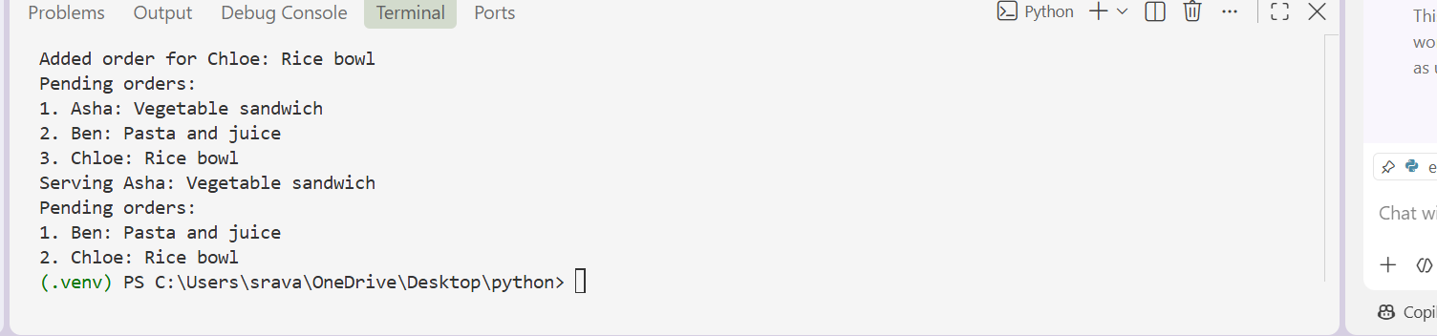
Task Description #8: Smart E-Commerce Platform – Data Structure
Challenge
An e-commerce company wants to build a Smart Online Shopping System
with:
1. Shopping Cart Management – Add and remove products
dynamically.
2. Order Processing System – Orders processed in the order they are
placed.
3. Top-Selling Products Tracker – Products ranked by sales count.
4. Product Search Engine – Fast lookup of products using product ID.
5. Delivery Route Planning – Connect warehouses and delivery
locations.
Student Task:
• For each feature, select the most appropriate data structure from
the list below:
o Stack
o Queue
o Priority Queue
o Linked List
o Binary Search Tree (BST)
o Deque
• Justify your choice in 2–3 sentences per feature.
• Implement one selected feature as a working Python program with
AI-assisted code generation.
Expected Output:
• A table mapping feature → chosen data structure → justification.
• A functional Python program implementing the chosen feature
with comments and docstrings.
PROMPT:
Create a Python e-commerce order processing system using a Queue.
Requirements:
- Orders must be processed using FIFO order.
- Create a class called OrderQueue.
- Implement place_order(order) to add an order.
- Implement process_order() to remove and process the oldest order.
- Implement display_orders() to show pending orders.
- Include docstrings and comments.
- Provide a simple demonstration with three orders.
- Follow PEP 8 coding standards.
CODE:
"""A simple FIFO queue for processing e-commerce orders."""

from collections import deque

class OrderQueue:
"""Store and process orders in first-in, first-out order."""

def __init__(self):
"""Initialize an empty queue of pending orders."""
self._orders = deque()

def place_order(self, order):
"""Add an order to the end of the queue."""
self._orders.append(order)
print(f"Order placed: {order}")

def process_order(self):
"""Process and return the oldest order, or report an empty queue."""
if not self._orders:
print("No pending orders to process.")
return None

# Remove the oldest order to preserve FIFO processing.
order = self._orders.popleft()
print(f"Processing order: {order}")
return order

def display_orders(self):
"""Display pending orders from oldest to newest."""
if not self._orders:
print("No pending orders.")
return

print("Pending orders:")
for order in self._orders:
print(f"- {order}")

if __name__ == "__main__":
order_queue = OrderQueue()
order_queue.place_order("Order #1001: Wireless mouse")
order_queue.place_order("Order #1002: Keyboard")
order_queue.place_order("Order #1003: Monitor")

order_queue.display_orders()
order_queue.process_order()
order_queue.display_orders()
OUTPUT:
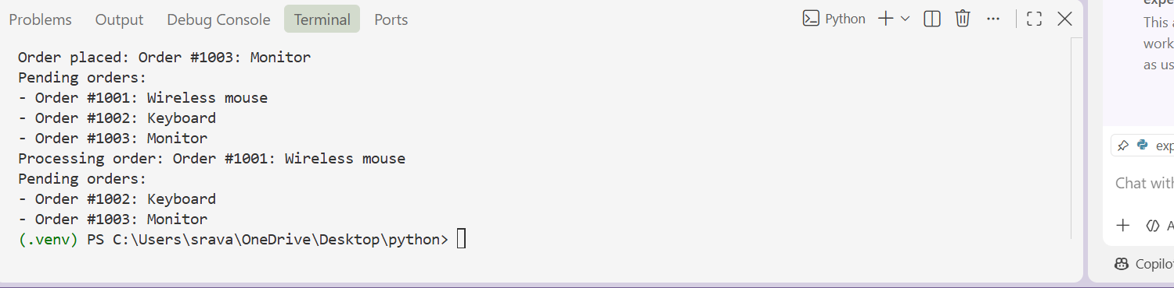
Conclusion:
This lab demonstrates how AI can assist in selecting, designing, documenting, and implementing fundamental data structures. Stack, Queue, Linked List, BST, Priority Queue, and Deque each solve different types of problems, and selecting the appropriate structure improves the efficiency, readability, and maintainability of software.

